Phonics lesson plans – long oo

DAY | We Are Learning To (WALT): | MODEL / INTRODUCTION | INDEPENDENT WORK | PLENARY
 | Recognise, read and spell the oo grapheme | Go through flashcards for today’s high frequency words  Revise the graphemes (letter strings) that we have covered previously – show children clue cards with each grapheme on the front and a clue word on the back. Have them say the clue word, then the sound that the grapheme represents e.g. bat, (b)  Show the children several images of words containing today’s grapheme/s  Say the word aloud that each image represents, without letting the children see the words  Ask children to think, pair, share which sound they can hear in all of the words  Ask children where the sound comes in the words i.e. at the beginning of the word, in the middle of the word at the end of the word, or in more than one position  Show children the images again, this time with the word underneath each image  Ask children to think, pair, share what pattern (i.e. what grapheme) they can see in all of the words  Show children images again, this time with the words under each image and the grapheme highlighted  Ask them to see if they spotted the pattern correctly  Discuss where in the words we find the grapheme  Have children repeat this phrase – ‘O O can represent (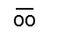)’  Repeat this phrase several times in different ‘voices’ e.g. loudly, quietly, quickly, slowly etc | Lower ability – circle the correct word (from a choice of 3 words) under a picture  Middle ability – join the correct letters together to make the word to go with a picture e.g.  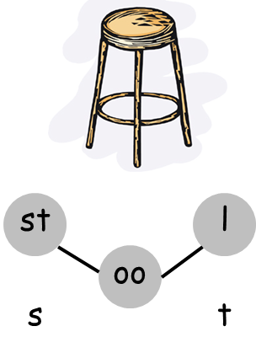  Higher ability – unscramble the letters to make the correct word to go with a picture e.g.  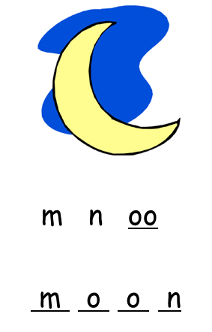  Extension – complete a Wordsearch with words with today’s grapheme | Revise the phrase for today: ‘O O can represent ()’  Ask children to think, pair, share as many of the words from today’s lesson as they can  Complete the additional IWB activities e.g. match the word and image and / or guess the missing word

© www.SaveTeachersSundays.com 2013

